Mary Alice (Lee) Sheets-Hoffman
June 23, 1928 – October 6, 2015
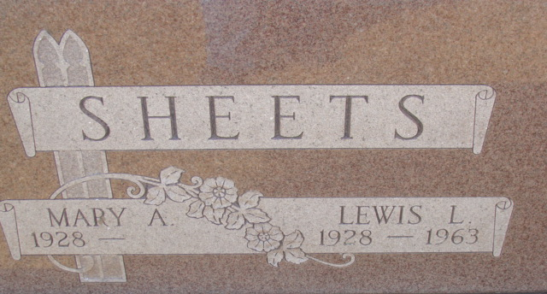
Photo by Alicia Kneuss
Mary Alice Hoffman, 87 years old of Decatur, Indiana, passed away on Tuesday, October 6, 2015 in the Adams Memorial Hospital located in Decatur. Mary was born on June 23, 1928 in Van Wert, Ohio the daughter of the late James G. Lee and the late Virdie (Taylor) Lee.
Her 1st husband, Lewis L. Sheets, married June 28, 1947 in Newport, KY and he passed away on May 5, 1963; and her 2nd husband was Harold C. Hoffman, they were married on September 1, 1967 in the Union Chapel Church - Decatur and he passed away on April 17, 2006.
Mary was a member of St. Paul Lutheran Church - Preble; Rivarre Chapter, Daughters of American Revolution; and the Lee County, Virginia Historical Society. Mary had been a realtor - auctioneer for Schenpf Realty retiring in 1982.
Surviving are her son, Michael D. (Diana) Hoffman of Decatur, IN; daughter, Vicki (Allan) Milholland of Decatur, IN; son, Thomas W. Sheets of Decatur, IN; daughter, Julie O'Beirne of Decatur, IN; daughter-in-law, Shirley Hoffman of Decatur, IN; son-in-law, Richard Penrod of Decatur, IN; daughter-in-law, Adele Sheets of San Diego, CA; 14 grandchildren: Michele (Jeffrey) Warner; Stephanie (Michael) Fawcett; Sarah (Jamie) Tharp; Nicholas (Rebecca) Hoffman; Jonathan (Leah) Sheets; Kristopher (Aideen) Sheets; Jennifer (Nick) Baughman; Tiffany Sheets; Matthew Sheets; Erin (Vinnie) Espinosa; Vincent (Amanda) Milholland; Ryan O'Beirne; Cole O'Beirne; & Logan O'Beirne; and 18 great-grandchildren: Jordan Warner; Jared (Steph) Fawcett; Britny Fawcett; Makayla Friedt; Isabelle Friedt; Isaac Friedt; Sydney Tharp; August Tharp; Emelia Hoffman; Quentin Espinosa; Adeline Espinosa; Wesley Milholland; Caitlin Sheets; Aimee Sheets; Ryan Sheets; Hailey Baughman; Madison Sheets; & Weston Sheets.
Preceding Mary in death were 2 sons, Ronald L. Hoffman & Jesse Sheets; 1 daughter: Ruth Ann Penrod; 1 grandson, Richard Penrod; 4 brothers: Abner, Harl, Herman & Charles Richard Lee; 4 sisters: Ruby Akins, Pauline Lopshire, Martha Lee, Juanita Eberle.
Funeral services will be held at 4:00 p.m. Friday, October 9, 2015 in the Zwick & Jahn Funeral Home with Rev. Dr. Daniel Brege officiating. Interment will follow in the Decatur Cemetery. Friends will be received from 4-8 p.m. Thursday, October 8, 2015 in the Zwick & Jahn Funeral Home, Decatur, IN and one hour prior to the service at the funeral home on Friday.
Preferred memorials are to Adams County Community Foundation - Angel Fund for Cancer Support; or donors' choice.

Zwick & Jahn Funeral Home, Adams County, Indiana
October 7, 2015

