Harry S. Sheets
June 16, 1906 – September 15, 1975

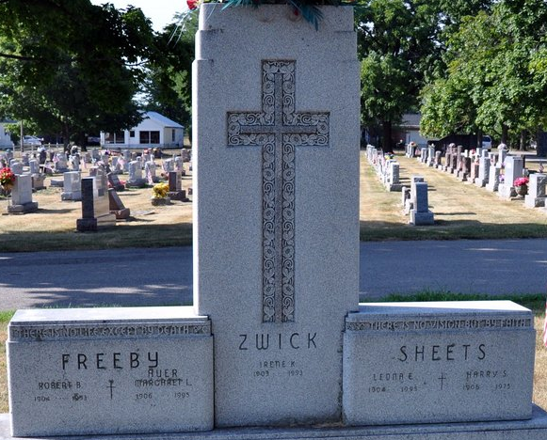
Photo by PLS

Harry S. Sheets
Harry S. Sheets, 69, 509 North Third St., who was in the retail plumbing and water conditioning business for many years, died at 7:05 a.m. today at the Adams County Memorial Hospital, where he had been a patient 10 days. He had been in failing health for several years. The well-known Decatur resident was a member of the Decatur Zion Lutheran Church and the Decatur Optimist Club.
Born in Wren, O., on June 16, 1906, he was a son of Samuel and Ada B. McGill-Sheets, and was united in marriage on March 13, 1937, to Leona E. Zwick, who survives.
Also surviving are three sons, James A. Sheets, New Castle; David R. Sheets, Hopkinsville, Ky., Stephen F. Sheets, Decatur; one sister, Mrs. Fred (Esther) McConnell, Decatur; three brothers, Richard Sheets, Paducah, Ky.; Everett Sheets, Decatur; Rex Sheets, Fort Wayne; and four grandchildren. Three brothers preceded him in death.
Funeral services will be held Wednesday at 1:30 p.m. at the Zwick Funeral Home and at 2 p.m. at the Zion Lutheran Church, with Rev. Richard C. Ludwig officiating. Burial will be in the Decatur Cemetery. Friends may call at the funeral home after 2 p.m. Tuesday until time of the services.

Decatur Daily Democrat, Adams County, Indiana
Monday, September 15, 1975

