Harlen L. Sheets
September 4, 1918 – December 26, 2007

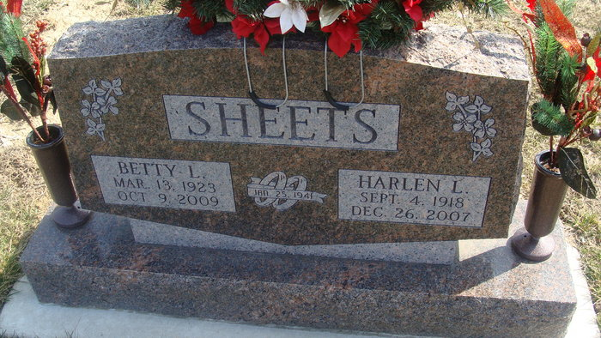
Photo by Alicia Kneuss

Harlen L. Sheets, 89 of Decatur died on December 26, 2007 at Adams Memorial Hospital. He was born in Wren, Ohio to the late Frank & Tulah (Woods) Sheets. He married Betty L. Garner on January 25, 1941. She survives.
Other survivors are a son Tim (Yvonda) Sheets of Wren, Ohio; 2 daughters Mrs. David (Linda) Gunsett and Mrs. Dee Busse both of Decatur; 11 grandchildren and 10 great grandchildren. Preceded him in death is a grandson Josh Busse.
Harlen attended the First United Methodist Church in Lake Placid, Florida. He worked for National Seal in Van Wert, Ohio for 32 years retiring in 1982.
Calling hours are 4-8 pm Sunday, December 30, 2007 at Haggard & Sefton Funeral Home. Funeral Services will be held at 10:00 am Monday, December 31, 2007 also at the funeral home. Rev. Jeff Taylor will be officiating and burial is in Decatur Cemetery.
Memorials are to Family Hospice of Northeast Indiana.

Haggard & Sefton Funeral Home, Adams County, Indiana
December 27, 2007

