Gerald R. Sheets
May 8, 1912 – September 21, 1972

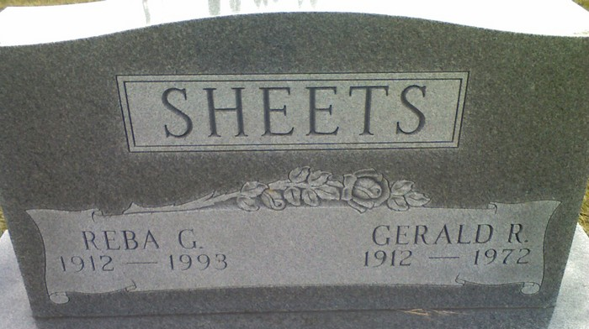
Photo of Alicia Kneuss

Gerald R. Sheets Dies at Hospital

Gerald R. Sheets, 60, of 803 N. Fifth Street, an employee for the Erie-Lackawanna Railroad 21 years, died at 3:30 a.m. this morning at the Adams County Memorial Hospital following a heart attack. He had been a patient at the hospital two weeks. Death was unexpected. Mr. Sheets also had a hauling route in Decatur.
Mr. Sheets was a member of the Mt. Pleasant United Methodist Church. He was born in Adams County May 8, 1912, a son of Soloman P. and Bertha Reinhart-Sheets, and was married to Reba Brown on September 18, 1938.
Survivors are the wife; one daughter, Mrs. Clark (Naomi) Jester of Decatur; two sons, John Paul, and Ron, both at home; one brother, Merle, of Fort Wayne; and two grandchildren. Two brothers, Chalmer and Chauncey, preceded him in death.
Funeral services will be conducted at 1:30 p.m. Saturday at the Zwick Funeral Home and at 2 p.m. at the Mt. Pleasant United Methodist Church, with Rev. Joseph Gibson officiating. Burial will be in the Decatur Cemetery. Friends may call at the Zwick Funeral Home after 12 noon Friday.

Decatur Daily Democrat, Adams County, Indiana
Thursday, September, 21, 1972

