Garry E. Sheets
August 24, 1940 – August 2, 1990

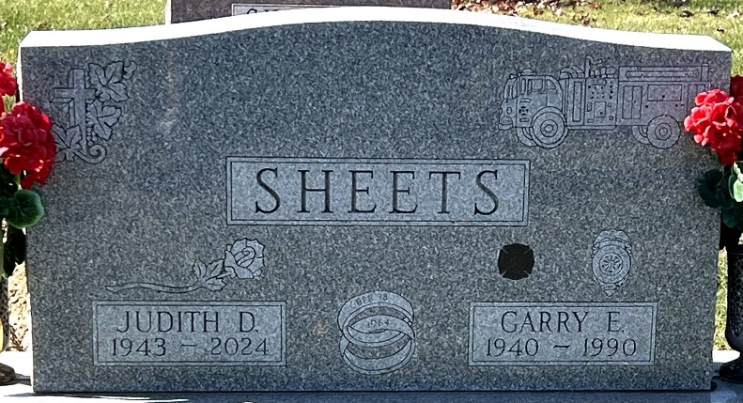
Photo by Deb Curry

Indiana, U.S., Death Certificates, 1899-2017
Name Garry E Sheets
Gender Male
Race White
Age 49
Marital Status Married
Birth Date 24 Aug 1940
Birth Place Decatur, Indiana
Death Date 2 Aug 1990
Death Place Fort Wayne, Allen, Indiana, USA
Death Registration Date 1990
Father Lester Sheets
Mother Isabel Sheehan
Spouse Judy Rawlings
Informant Judy Sheets; wife; Decatur, Indiana
Burial Decatur Cemetery Aug 5, 1990

