Faye Ann Sheets
May 3, 1933 – April 1, 1947

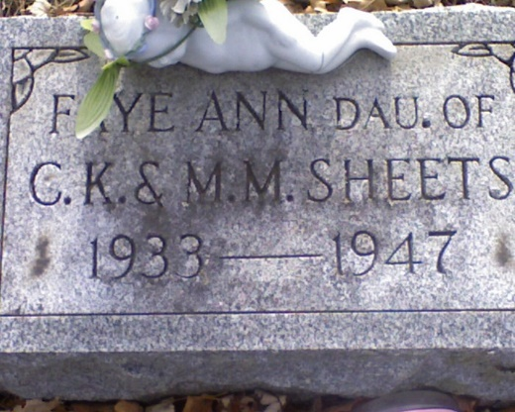
Photo by Deb Curry

FAYE ANN SHEETS DIES LAST NIGHT
Funeral Services Saturday Afternoon

Miss Faye Anne Sheets, 13, daughter of Mr. and Mrs. Chalmer K. Sheets, east of Decatur, died at 9:35 o'clock Tuesday night at the Riley Hospital in Indianapolis, where she underwent an operation for a brain tumor several days ago. She had been ill for six months.
She was born in Adams County, May 3, 1933, a daughter of Chalmer K. and Melvina Smitley-Sheets.
She was a member of the Union Chapel Evangelical United Brethren Church.
Surviving in addition to the parents are 10 brothers and sisters, Deloris, Josephine, Betty, Mary, Max, Lester, Esther, Jay Allen, Caroline Sue and Sally Jo Sheets, all at home; and the grandparents, Mr. and Mrs. J. B. Smitley of Decatur and Mrs. Lloyd Ruse, also of Decatur.
Funeral services will be held at 1:30 p.m. Saturday at the Black Funeral Home and at 2 o'clock at the Trinity Evangelical United Brethren Church, with the Rev. H. Pellett and the Rev. C. White officiating. Burial will be in the Decatur Cemetery. Friends may call at the funeral home ...7 o'clock Thursday.

Unknown source
Handwritten date: 1947

**
Faye Ann Sheets from tree BIRD FAMILY TREE
Birth 3 May 1933 Decatur, Adams, Indiana, USA
Residence 1940 Adams, Indiana, USA
Death 1 Apr 1947 Indianapolis, Marion, Indiana, USA
Father Chalmer Kern Sheets (1902-1970)
Mother Melvena Mae Smitley (1910-1963)

