Ethel C. (Wynn) Sheets
November 21, 1900 – May 26, 1972

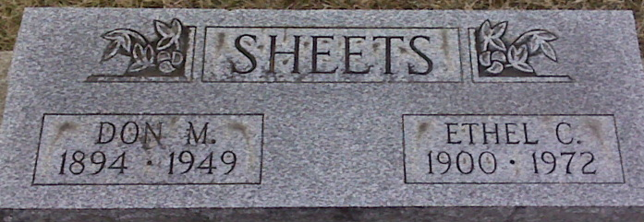
Photo by Lee Sheets

Ethel C. Sheets Dies at Hospital

Mrs. Ethel C. Sheets, 71, of 919 Winchester Street, widow of Don M. Sheets, died at 6:30 a.m. today at the Adams County Memorial Hospital, where she had been a patient four two weeks.
She was born in Adams County Nov. 21, 1900, a daughter of R. M. And Sophia Gross-Wynn, and was married to Don M. Sheets Oct. 16, 1920. Her husband preceded her in death Feb. 14, 1949.
Mrs. Sheets, an employee of the Schafer Glove Co. for many years until retirement, was a member of the Church of God.
Surviving are four sons, Robert and Buddy D. Sheets, both of Decatur, Glenn Sheets of Belleville, Ill., and Richard Sheets of Marion; three daughters, Mrs. Roy (Catherine) Warren of Fort Wayne, Mrs. Elizabeth McCullough and Miss Betty Sheets, both of Decatur; four sisters, Mrs. Harold (Helen) Baughn of Decatur, Mrs. Ted (Mina) August of New Haven, Mrs. Frank (Marge) Rose of Ft. Myers, Fla., and Mrs. Dwight (Gladys) Darr of Decatur route 5; one brother, Rube Wynn of Decatur; 13 grandchildren and three great-grandchildren. One son, William, one sister and two brothers are deceased.
Funeral services will be conducted at 2 p.m. Sunday at the Zwick funeral home, with Rev. Artie Burnett officiating. Burial will be in the Decatur Cemetery. Friends may call at the funeral home after 2 p.m. Saturday until time of the services.
Preferred memorials are to the Arthritic Foundation.

Decatur Daily Democrat, Adams County, Indiana
Friday, May 26, 1972

