Edna Nettie (Speakman) Sheets
February 22, 1907 – December 3, 1966

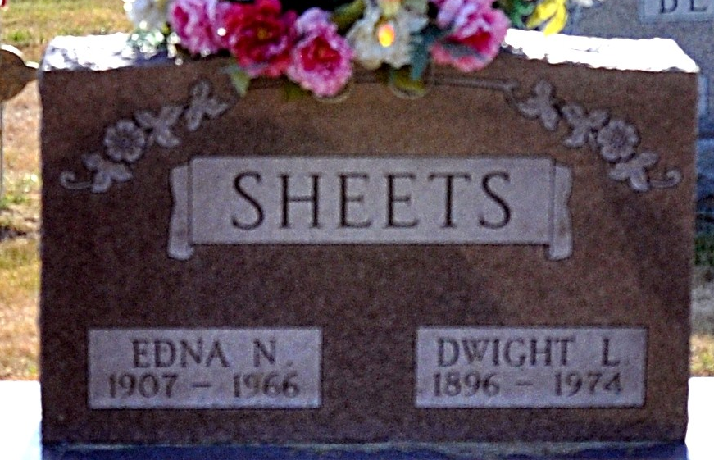
Photo by Deb Curry

Edna Nettie Sheets
in the Indiana, U.S., Death Certificates, 1899-2017
Name Edna Nettie Sheets
Maiden Name Speakman
Gender Female
Race Caucasian (White)
Age 59
Marital Status Married
Birth Date 22 Feb 1907
Birth Place Indiana
Death Date 3 Dec 1966
Death Place Decatur, Adams, Indiana, USA
Death Registration Date 1966
Father William Speakman
Mother Ella Smitley
Informant Dwight L Sheets; husband; Decatur, Indiana
Burial December 6, 1966; Decatur Cemetery; Decatur, Indiana

