Dwight L. Sheets
December 22, 1896 – Marche 22, 1974

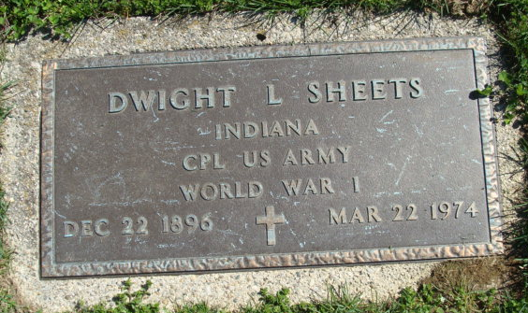
Photo by Alicia Kneuss

Dwight Luman Sheets
in the Indiana, U.S., Death Certificates, 1899-2017

Name Dwight Luman Sheets
Gender Male
Race White
Age 77
Marital Status Widowed
Birth Date 22 Dec 1896
Birth Place Ohio
Death Date 22 Mar 1974
Death Place Decatur, Adams, Indiana, USA
Death Registration Date 1974
Father Samuel P Sheets
Mother Addie McGill
Informant Dwight L. Sheets, Jr.; son; Decatur, Indiana
Burial March 25, 1974; Decatur Cemetery, Decatur, Indiana

