Doyle Leslie Sheets
January 30, 1923 – July 20, 2019

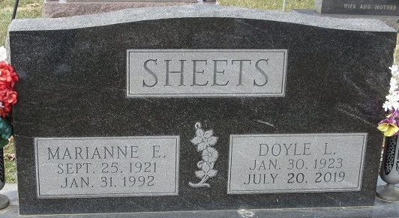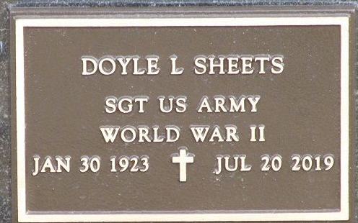
Photo by PLS

Doyle Sheets, 96 died July 20, 2019. Born in Decatur, he was the son of Noah and Marie (Teeple) Sheets. Doyle was a graduate of Decatur High School Class of 1941. He was a WW 2 Army veteran and fought in Normandy, Germany and Central Europe with the 75th Armored Battalion. He worked at GE his entire career. He married Marianne Klarowski in 1946 and they lived in Fort Wayne. She preceded him in death in 1992.
Doyle enjoyed bowling well into his 80’s. He created many memories with his children and grandchildren in Indiana, Vermont and Michigan that will be cherished forever. Doyle was a happy man, full of pranks and a snappy wit that even blindness could not diminish.
Survivors include daughter, Kathleen (Ken) Ehinger of Coldwater, MI.; son, Ron Sheets of Fort Wayne, IN; sister, Martha “Marty” Reef of Decatur, IN; six grandchildren; Audrey Beacom, Rachel Savoie, Keith Ehinger, Luke Ehinger, Dan Ehinger, Nikki Sheets and six great-grandchildren. He was preceded in death by four brothers: Robert, David, Raymond and Richard Sheets and two sisters; Alice (Harman) Hunter and Helen Morgan.
Funeral services will be held Thursday July 25 at 10:30 a.m. at the Zwick & Jahn Funeral Home, Decatur, IN. Interment will follow at the Decatur Cemetery with Military Honors by American Legion Post 43, Decatur.
Friends will be received Wednesday July 24 from 4:00 p.m.- 8:00 p.m. at the Zwick & Jahn Funeral Home, Decatur, IN.
Preferred memorials are to Southwest Conservation Club 5703 Fort Wayne, or VFW Jim Eby Post 857, Fort Wayne.

Zwick & Jahn Funeral Home, Adams County, Indiana
July 21, 2019

