Dorothy E. (Voirol) Sheets
June 7, 1919 – November 17, 2004

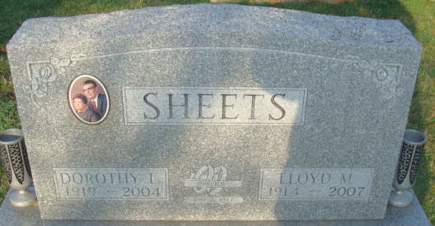
Photo by Alicia Kneuss

Dorothy E. Sheets

Dorothy E. Sheets, 85, Decatur, died at 10:56 p.m. Wednesday in Adams Memorial Hospital. She was born on June 7, 1919, in Allen County to Edward F. and Louise Lamblin Voirol. She married Lloyd M. Sheets on May 2, 1942; he survives.
She was a homemaker who also worked for two years at the General Electric Co. plant in Fort Wayne. She was a member of St. Mary of the Assumption Catholic Church in Decatur.
Other survivors are two sisters, Betty Fiedler of Fort Wayne and Edna Miller of Shipshewana, and a brother, Robert Voirol of Albion. Four brothers and three sisters are deceased. Funeral services will be held at 11 a.m. Saturday in Zwick and Jahn Funeral Home, Decatur, with burial in Decatur Cemetery. Visiting hours are 5-8 p.m. today, with a rosary service at 5 p.m.
Preferred memorials are to the church for masses or to the American Lung Association.

Decatur Daily Democrat, Adams County, Indiana
Friday, November 19, 2004

