Doris E. (Durbin) Sheets
September 10, 1919 – August 21, 2018

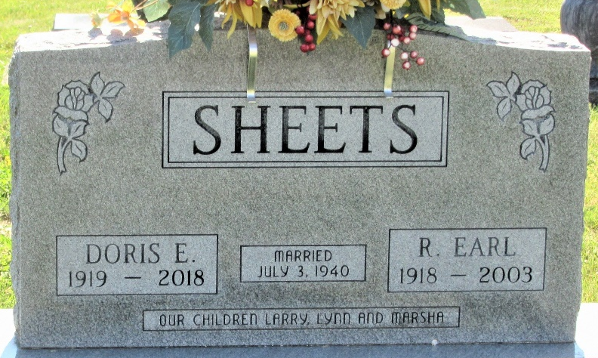
Photo by PLS

Doris E. Sheets, 98, Decatur, passed away Friday, Aug. 31, 2018, at Golden Years Nursing Home in Fort Wayne. Doris was born in Cando, North Dakota, Sept. 10, 1919, to the late Harold H. and Maude S. (Case) Durbin. On July 3, 1940, she married R. Earl Sheets; he preceded her in death in 2003 after 63 years of marriage.
She was an active member of First United Methodist Church in Decatur, where she served on many boards and committees. She was involved with the United Methodist Women and the Rebecca Circle.
Doris was a graduate of St. Joseph School of Nursing. She and her husband Earl were the owners of Sheets Furniture in downtown Decatur for many years.
Among survivors are two sons, Larry R. (Genette) Sheets of Dayton, Ohio, and Lynn A. (Sharon) Sheets of Defiance, Ohio; a daughter, Marsha (Doug) Worthington of Fort Wayne; a sister, Betty Holtzberg of Flat Rock, North Carolina; two half-brothers, Melvin and James Holien, both of Spokane, Washington; seven grandchildren, 20 great-grandchildren and two great-great-grandchildren.
She was preceded in death by a brother, Fred Noll; a half-sister, Dolly; and three half-brothers, Melvin, Roy and Clifford.
Funeral services will be at 12 p.m. Saturday at First United Methodist Church, with visitation two hours prior to the service from 10 a.m.-12 p.m. Officiating will be her grandson, Pastor Rick Sheets. Burial will take place in the Decatur Cemetery.
Preferred memorials are to the First United Methodist Church, Decatur.
Decatur Daily Democrat, Adams County, Indiana
September 4, 2018

**
U.S., Cemetery and Funeral Home Collection, 1847-Current
Name Doris E. Sheets
[Doris E. Durbin]
Gender Female
Death Age 98
Birth Date 10 Sep 1919
Birth Place Cando, North Dakota
Marriage Date 3 Jul 1940
Residence Place Decatur, IN
Death Date 31 Aug 2018
Death Place Fort Wayne
Burial Date 8 Sep 2018
Father Harold H. Durbin
Mother Maude S. Durbin [Case]
Spouse R. Earl Sheets
Child Marsha Worthington, Lynn A. Sheets. Larry R. Sheets
Siblings James Holien, Melvin Holien, Clifford, Betty Holtzberg, Dolly, Fred Noll, Roy

