Don M. Sheets
September 5, 1894 – February 14, 1949

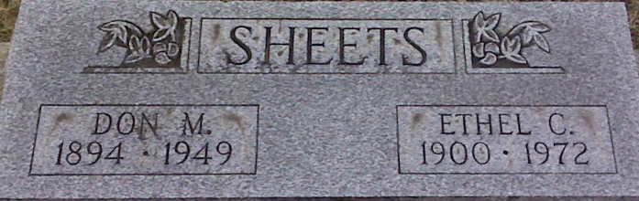
Photo of Alicia Kneuss

Indiana, Death Certificates, 1899-2011 (text only)
Name Don M Sheets
Gender Male
Race White
Age 54y 5m 9d
Marital Status Married
Birth Date 5 Sep 1894
Birth Place Adams Co Indiana
Death Date 14 Feb 1949
Death Place Decatur, Whitley, Indiana, USA
Death Registration Date 1949
Father Christ C Sheets
Mother Dora Kettle
Informant Mrs. R. C. Warren, Decatur, IN
Burial Decatur Feb. 17, 1949

