David L. Sheets
November 9, 1932 – May 31, 1999

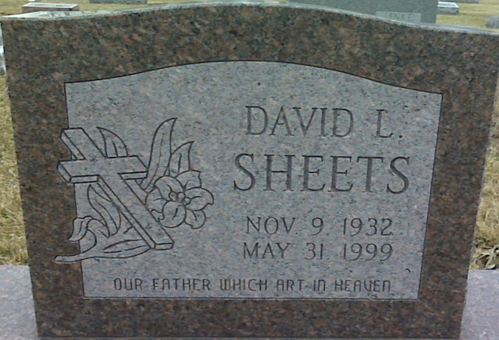
Photo by Alicia Kneuss

David L. Sheets, 66, died Monday at Harborside Healthcare, New Haven. Born in Decatur, he was assistant manager at Pine Valley True Value Hardware and was formerly employed at Hardware Wholesalers in Fort Wayne.
Surviving are three daughters, Deborah Werling and Denise Frazier, both of New Haven, and Diana Sheets of Fort Wayne; two sisters, Alice C. Hunter and Martha E. Reef, both of Decatur; a brother, Doyle L. of Fort Wayne; and five grandchildren.
Services at 10 a.m. Friday at Zwick & Jahn Funeral Home, Decatur, with calling from 2 to 4 and 6 to 8 p.m. Thursday. Burial at Decatur Cemetery.
Memorials to South Wayne United Methodist Church, Fort Wayne, and Cancer Services of Allen County.

Journal Gazette, Allen County, Indiana
Wednesday, June 2, 1999
**
Indiana, U.S., Death Certificates, 1899-2017
Name David L Sheets
Gender Male
Race White
Age 66
Marital Status Divorced
Birth Date 9 Nov 1932
Birth Place Indiana
Death Date 31 May 1999
Death Place New Haven, Allen, Indiana, USA
Death Registration Date 1999
Father Noah Sheets
Mother Mary Teeple
Informant Mrs. Denise Frazier; daughter; New Haven, Indiana
Burial June 4, 1999; Decatur Cemetery; Decatur, Indiana

