Dale Reinhart Sheets
October 5, 1961 – April 14, 1963

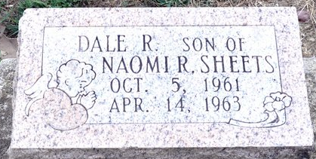
Photo by Deb Curry

Sheets Child Dies After Brief Illness

Dale Reinhart Sheets, 18 months of 803 North Fifth street, died at 10 o’clock Sunday at the Lutheran hospital in Fort Wayne. The child has been ill for one week and had been hospitalized for four days.
Surviving is the mother, Naomi; the grandparents, Mr. and Mrs. Gerald Sheets of Decatur, and the great-grandmother, Mrs. Bertha Ruse of Decatur.
Funeral services will be conducted at 1:30 p.m. Tuesday at the Zwick Funeral Home the Rev. Kenneth Angle officiating. Burial will be in the Decatur Cemetery. Friends may call at the funeral home after 7 p.m. today until time of the services.

Berne Library Heritage Room, Adams County, Indiana
Adams County Obits 1962-1964
Handwritten date: Monday, April 15, 1963

**
Indiana, U.S., Death Certificates, 1899-2017
Name Dale Reinhart Sheets
Gender Male
Race White
Age 1
Marital Status Never Married (Single)
Birth Date 5 Oct 1961
Birth Place Decatur Indiana
Death Date 14 Apr 1963
Death Place Fort Wayne, Allen, Indiana, USA
Death Registration Date 1963
Father Robert Engle
Mother Naomi Sheets
Informant Naomi Sheets; mother; Decatur, Indiana
Burial April 17, 1963; Decatur Cemetery; Decatur, Indiana

