Christopher C. Sheets
November 23, 1868 – March 25, 1940

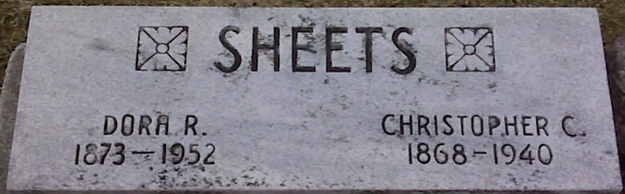
Photo by Alicia Kneuss

Christian C Sheets
in the Indiana, U.S., Death Certificates, 1899-2017
Name Christian C Sheets
Gender Male
Race White
Age 72
Marital Status Married
Birth Date 23 Nov 1867
Birth Place Adam County Indiana
Death Date 25 Mar 1940
Death Place Fort Wayne, Allen, Indiana, USA
Death Registration Date 1940
Father Noah S Sheets
Mother Sarah Pryor
Spouse Dora Kittle
Informant True Sheets; Fort Wayne, Indiana
Burial March 28, 1940; Decatur Cemetery; Decatur, Indiana

