Chauncey A. Sheets
December 17, 1900 – February 15, 1972

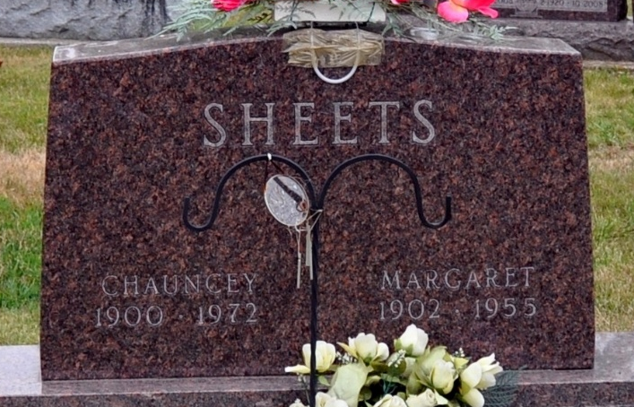
Photo by Deb Curry

Chauncey Sheets Dies in Florida

Chauncey A. Sheets, 71, retired farmer of Decatur route 2, died unexpectedly this morning at the Manatee Memorial Hospital at Bradenton, Fla., where he had been a patient five days. Mr. Sheets resided during the winter months at 30 Riverview Drive, Ellington, Fla., since retiring.
Born in Adams County Dec. 17, 1900, he was a son of Solomon P. and Bertha Reinhart-Sheets and was first married to Margaret Kidwell April 11, 1925. She preceded him in death Aug. 11, 1955. He was married in May of last year to Delia Raybrouck, who survives.
Mr. Sheets was a member of the Mt. Pleasant United Methodist church.
Surviving in addition to his wife are five sons; Brice of Decatur route 2, Charles of Decatur, Marion of Greenwood, Norman of Decatur route 2, and Leo of Venice, Fla.; one daughter, Mrs. Robert (Violet) Sprague of Fort Wayne; two brothers, Gerald Sheets of Decatur, and Merle Sheets of Fort Wayne; 16 grandchildren and two great-grandchildren. One brother, Chalmer, is deceased.
The body will be returned to the Zwick Funeral Home for services and burial.
Decatur Daily Democrat, Adams County, Indiana
Tuesday, February 15, 1972
**
Rites Friday for Chauncey Sheets

Funeral services for Chauncey A. Sheets, who died Tuesday morning in Florida, will be conducted at 1:30 p.m. Friday at the Zwick Funeral Home, with Rev. Joseph Gibson officiating. Burial will be in the Decatur Cemetery. Friends may call at the funeral home after 12 noon Thursday until time of the services.

Decatur Daily Democrat, Adams County, Indiana
Wednesday, February 16, 1972

