Chalmer Kern Sheets
October 6, 1902 – October 24, 1970

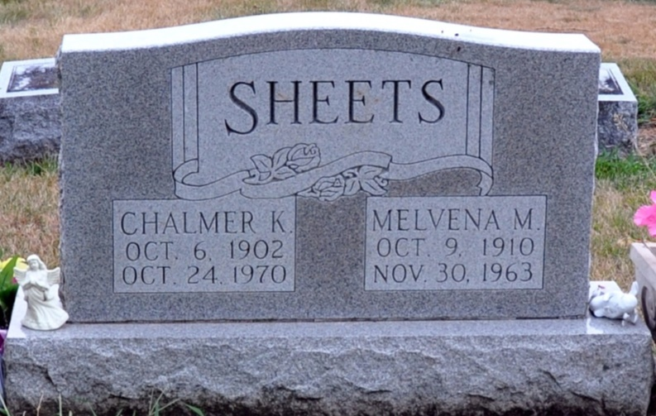
Photo by Alicia Kneuss

Chalmer K. Sheets Dies at Hospital

Chalmer K. Sheets, 68, of 717 North Second Street, a retired farmer, died at 7:47 Saturday at the Adams County Memorial Hospital, following a serious illness of two weeks.
A lifelong resident of Adams County, he was born to Solomon P. and Bertha Reinhart-Sheets Oct. 6, 1902, and was married to Melvina Smitley March 23, 1930. His wife preceded him in death Nov. 30, 1963.
Surviving are seven daughters, Mrs. Homer (Deloris) Tschannen, and Mrs. Jack (Josephine) Weldy, both of Decatur, Mrs. John (Betty) Overholser of Royal Center, Mrs. William (Mary) McCarty of Cutler, Mrs. Don (Esther) Peterson and Mrs. Richard (Carolyn) Marbaugh, both of Decatur, an Mrs. Richard (Sally) McDonough of Marion, O.; three sons, Max Sheets of Bluffton, Lester Sheets of Berne Route 1, and Jay Sheets of Decatur; three brothers, Chauncey and Gerald Sheets, both of Decatur, and Merle Sheets of Fort Wayne; and 42 grandchildren. One daughter is deceased.
Funeral services will be conducted at 1 p.m. Tuesday at the Zwick Funeral Home, with Rev. L.T. Norris and Rev. Richard Dolby officiating. Burial will be in the Decatur Cemetery. Friends may call at the funeral home until time of the services.

Decatur Daily Democrat, Adams County, Indiana
Monday, October 26, 1970

