Carl D. Sheets
March 4, 1916 – October 2, 1994

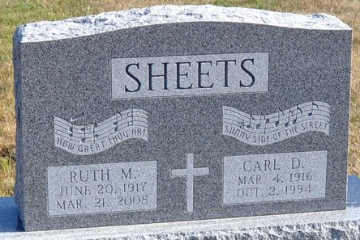
Photo by Deb Curry

Indiana, Death Certificates, 1899-2011
Name: Carl D Sheets
Gender: Male
Race: White
Age: 78
Marital status: Married
Birth Date: 4 Mar 1916
Birth Place: Van Wert, Ohio
Death Date: 2 Oct 1994
Death Place: Decatur, Adams, Indiana, USA
Father: Raymond O Sheets
Mother: Fern L Walters
Spouse: Ruth Bushong
Informant: Ruth Sheets, wife
Burial: Oct 5, 1994 Decatur Cemetery

