Buddy Don Sheets
November 10, 1932 – October 29, 2020

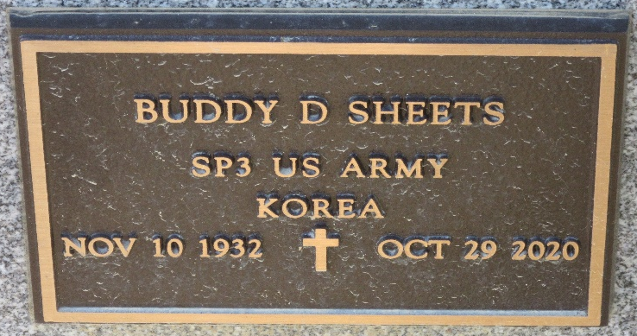
Photo of PLS
Buddy D. Sheets, 87, of Decatur, Indiana passed away Thursday morning, October 29, 2020, at his residence. He was born November 10, 1932 in Portland, Indiana to Don M. and Ethel C. (Wynn) Sheets. On June 27, 1953, he married Wilma Joan Case.
Buddy served his country in the United States Army during the Korean Conflict from August 1954 to August 1956. He was a member of St. Mark’s United Methodist Church and the American Legion Post #43, both in Decatur.
He retired in December of 1994 from Central Soya with 43 years of service. Following his retirement, Buddy worked at Universal Metalcraft for 20 years. Buddy loved sports especially IU basketball, Cubs baseball, and Bears football. He especially enjoyed watching his grandkids sports...soccer, softball, wrestling, and golf. He was quite the carpenter, doing things for all the family and friends too. He enjoyed playing golf with his wife, Joan, children, and grandchildren!
He is survived by his wife of 67 years, Joan Sheets of Decatur, Indiana; daughter, Christine J. (Michael) Cloud of Decatur, Indiana; two sons, Jeffrey A. (Jennifer) Sheets and David E. (Teresa) Sheets both of Decatur, Indiana; sister, Elizabeth McCullough of Decatur, Indiana; granddaughters, Tessa (Shane) Rekeweg and Holly Sheets; grandsons, John (Belem) Sheets, William (Rachel) Sheets, and Marc (Courtney) Sheets; and great-grandchildren, Alexa & Yogi Rekeweg, Jaxon Evans, Eva Nicole and Gabriel Sheets. He was preceded in death by his parents; two sisters, Catherine Crowl and Betty Sheets; and four brothers, Robert Sheets, William Sheets, Richard Sheets, and Glenn Sheets.
Due to COVID-19, private family services will be held with burial at Decatur Cemetery.
Preferred memorials are to St. Mark’s United Methodist Church or Adams County Community Foundation Cancer Fund.

Zwick & Jahn Funeral Home, Adams County, Indiana
October 30, 2020

