Brice F. Sheets
February 24, 1926 – August 1, 2018

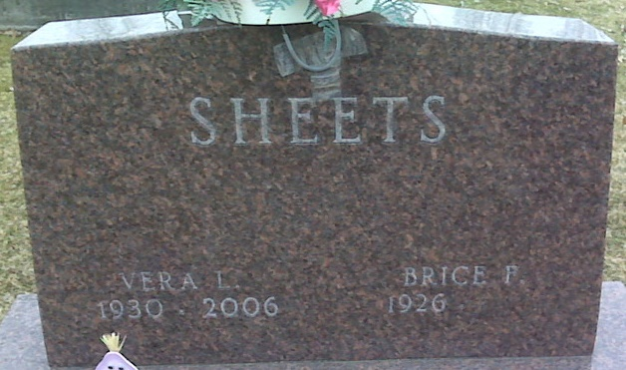
Photo by Lee Sheets

Brice F. Sheets, 92, of Decatur, passed away Wednesday, August 1, 2018 at Adams Woodcrest in Decatur. He was born on February 24, 1926 in Decatur, Indiana the son of the late Chancy Sheets and the late Margaret (Kidwell) Sheets. He married Vera (Cottrell) Sheets on June 20, 1948 in rural Decatur, Indiana and she preceded him in death on June 29, 2006.
Brice was an honorably discharged member of the United States Army. He served during World War II from 1944 - 1945 in the Pacific Theater of Operations and was discharged at the rank of Sergeant.
Brice retired from Adams County Sheriff's Department in 1988 where he supervised the first work release detail operated by the Sheriff's Department. Prior to his service with the Sheriff's Department, Brice was employed by the Adams County Highway Department as a truck mechanic for 20 years.
Brice loved his family. They were the most important part of his life. He was very generous with his time, helping others whenever possible…a great friend to many. Brice was a member of the American Legion Post #43 in Decatur.
Survivors include three sons, James (Susan) Sheets of Geneva, Jeff Sheets of Decatur, and Brice A. Sheets of Decatur; daughter, Carol (Gary) Frauhiger of Fort Wayne; sister, Violet (Bob) Sheets - Sprague of Fort Wayne; two brothers, Marion Sheets of Greenwood, IN and Leo Sheets of Venice, FL; seven grandchildren and ten great grandchildren. He was preceded in death by his daughter Linda F. Sheets; great granddaughter, Gabrielle Frauhiger and two brothers, Norman Sheets and Charles Sheets.
Funeral services will be held at 10:30 a.m. Monday, August 6, 2018 at Zwick & Jahn Funeral Home- Decatur. Interment will follow in the Decatur Cemetery in Decatur, Indiana. Friends will be received from 12 noon to 2:30 p.m. Sunday in the Zwick & Jahn Funeral Home- Decatur and one hour prior to services Monday also at the funeral home.
Preferred memorials are to the Honor Flight NE Indiana or Adams Post #43 Color Guard.

Zwick & Jahn Funeral Home, Adams County, Indiana
August 2, 2018

