Bertha (Rinehart) Sheets-Bigley
October 31, 1881 – May 11, 1970

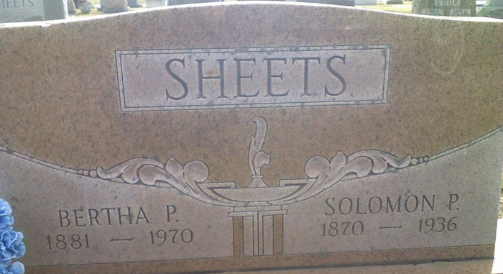
Photo of Lee Sheets

Mrs. Bertha Bigley Dies at Hospital

Mrs. Bertha Sheets Bigley, 88, of Oregon, O., a native and resident of Adams County most of her life, died at 1:40 p.m. Monday night at the Adams County Memorial Hospital, where she had been a patient two weeks.
She was born in Adams County Oct. 31, 1881, a daughter of William and Barbara Weldy-Rinehart. Her first husband, Sol Sheets, preceded her in death in 1936. She was married Sept. 17, 1964, to Chester O. Bigley, who survives. They have resided in Oregon, O., for five years.
Mrs. Bigley was a member of the First United Methodist Church.
Surviving are her husband; four sons, Chauncy A. Sheets of Decatur Route 2, Chalmer K. and Gerald R. Sheets, both of Decatur, and Merle L. Sheets of Fort Wayne; two stepdaughters, Mrs. Tillman (LaVerta) Corum of Oregon, O., and Mrs. George (Dorothy) Foldvary of Toledo, O.; one sister, Mrs. Jessie Moore of Elkhart, a half-sister, Mrs. Mary Doctor of Fort Wayne; 22 grandchildren, 70 great-grandchildren, one great-great-grandchild, five step-grandchildren, and 14 step-great-grandchildren. Three sisters and two brothers are deceased.
Funeral services will be conducted at 2 p.m. Thursday at the Winteregg-Linn Funeral Home, with Rev. Melvin Seeger officiating. Burial will be in the Decatur Cemetery. Friends may call at the funeral home after 7 p.m. today until time of the services. Preferred memorials are to the Cancer Fund.

Decatur Daily Democrat, Adams County, Indiana
Tuesday, May 12, 1970

**
Name: Amos Lloyd Ruse
Sex: Male
Residence Place: Decatur, , Indiana
Birth Date: 21 Nov 1880; Birthplace: , Huntington, Indiana
Race: White
Number of Previous Marriages: 3
Father's Name: William Ruse
Mother's Name: Hester Ann Sutton
Spouse's Name: Bertha P Sheets
Spouse's Sex: Female
Spouse's Residence Place: Decatur, , Indiana
Spouse's Birth Date: 31 Oct 1881; Spouse's Birthplace: , Adams, Indiana
Spouse's Race: White
Spouse's Previous Marriage Number: 2
Spouse's Father's Name: William D Rinehart
Spouse's Mother's Name: Barbara S Weldy
Officiator's Name: M O Lester
Marriage License Date: 30 Dec 1944
Marriage License Place: Adams, Indiana, United States
Marriage License Place (Original): ADAMS, Indiana, United States
Number of Images: 1
Page: 475
Digital Folder Number: 004186033
Microfilm Number: 002321635
Image Number: 00713
Indexing Batch: M02124-8
Citing this Record
"Indiana Marriages, 1811-2019," database with images, FamilySearch (https://www.familysearch.org/ark:/61903/1:1:XXJ1-23X : 8 April 2021), Amos Lloyd Ruse and Bertha P Sheets, 30 Dec 1944; citing Adams, Indiana, United States, Marriage License, Indiana Commission on Public Records, Indianapolis; FHL microfilm 004186033.

