Betty L. (Garner) Sheets
March 13, 1923 – October 9, 2009

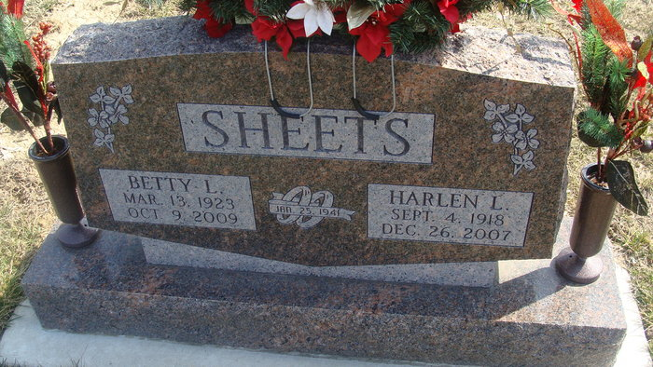
Photo by Alicia Kneuss

Betty L. Sheets, 86, of Decatur, passed away Friday, Oct. 9, 2009, at Adams Memorial Hospital, Decatur. She was formerly of Van Wert, Ohio for 45 years, and Lake Placid, Fla., for 20 years.
Born March 13, 1923 in Decatur, she was the daughter of the late Paul W. and Velma J. (Niblick) Garner. She married Harlen L. Sheets on Jan. 1, 1941; he passed away on Dec. 26, 2007. She attended First United Methodist Church in Lake Placid, Fla., and most recently attended Zion Lutheran Church in Decatur. She retired in 1985 after 35 years of service with National Seal (now known as Federal Mogul) in Van Wert, Ohio.
She is survived by one son, Tim (Yvonda) Sheets of Wren, Ohio; two daughters, Mrs. David (Linda) Gunsett and Mrs. Denise "Dee" Busse, both of Decatur; three sisters, Marsha "Marty" Stetler, Wanda Jean Eyanson and Shirley Adams, all of Decatur; 10 grandchildren; and 13 great-grandchildren. She was also preceded in death by a grandson Josh Busse.
Funeral Service is 10 a.m. Tuesday at Haggard & Sefton Funeral Home; Rev. Phil Phifer officiating. Visitation from 4 to 7 p.m. Monday at the funeral home. Burial in the Decatur Cemetery.
Memorials to Adams Wells Crisis Shelter or to the A.C.C.F. Angel Cancer Fund.

Haggard & Sefton Funeral Home, Adams County, Indiana
October 10, 2009

