Betty Ann Sheets
November 9, 1927 – August 10, 1993

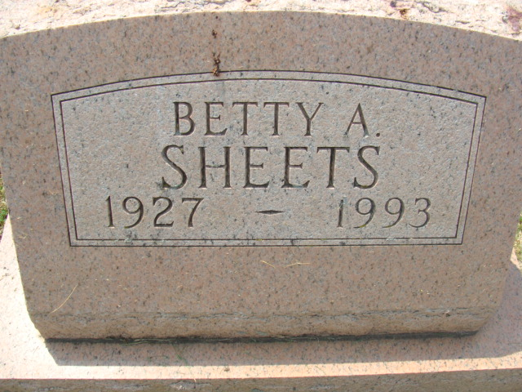
Photo by Alicia Kneuss

Betty Ann Sheets
in the Indiana, U.S., Death Certificates, 1899-2017
Name Betty Ann Sheets
Gender Female
Race White
Age 65
Marital Status Never Married (Single)
Birth Date 9 Nov 1927
Birth Place Decatur, Indiana
Death Date 10 Aug 1993
Death Place Decatur, Adams, Indiana, USA
Death Registration Date 1993
Father Don M Sheets
Mother Ethel C Wynn
Informant Buddy Sheets; brother; Decatur, Indiana
Burial August 13, 1993; Decatur Cemetery; Decatur, Indiana

