Addie Viora (Woods) Sheets
November 12, 1893 – May 31, 1969

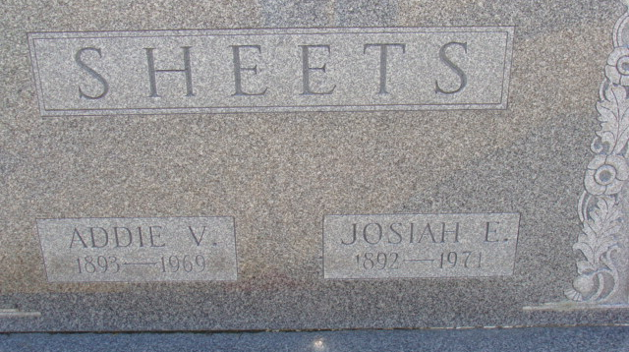
Photo of Alicia Kneuss

ADDIE V. SHEETS
DECATUR – Addie V. Sheets, 75, a native of Van Wert County died at 11:05 a.m. Saturday in Adams County Memorial Hospital, Decatur, following an illness of 14 months.
Survivors include her husband, Jesse, of Decatur; two sons, Lloyd and Lester, both of Decatur; two daughters, Mrs. Lendell Milheim of Tecumseh, Mich., and Mrs. Miles Nishiyama [sic] of Grand Rapids, Mich.; and a sister, Mrs. Otto Sullivan of Fort Wayne.
Funeral services will be at 1:30 p.m. Tuesday at Zwick Funeral Home with the Rev. Richard Dolby and the Rev. L. T. Norris officiating. Burial will be in Decatur Cemetery. Friends may call at the funeral home.

Van Wert Times Bulletin, Van Wert County, Ohio
Monday, June 2, 1969

**
Indiana, U.S., Death Certificates, 1899-2017
Name Addie Viora Sheets
[Addie Viora Woods]
Gender Female
Race White
Age 75
Marital Status Married
Birth Date 12 Nov 1893
Birth Place Ohio
Death Date 31 May 1969
Death Place Decatur, Adams, Indiana, USA
Death Registration Date 1969
Father: David Woods
Mother: Adeline McClure
Spouse: Josiah E Sheets
Informant: Jesse E. Sheets; husband; Decatur, Indiana
Burial: June 3, 1969; Decatur Cemetery; Decatur, Indiana

