Thomas A. Sheehan
April 30, 1911 – November 8, 1986

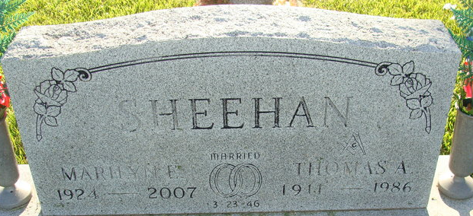
Photo by Alicia Kneuss

Thomas A Sheehan
in the Indiana, U.S., Death Certificates, 1899-2017
Name Thomas A Sheehan
Gender Male
Race White
Age 75
Marital Status Married
Birth Date 30 Apr 1911
Birth Place Indiana
Death Date 8 Nov 1986
Death Place Decatur, Adams, Indiana, USA
Death Registration Date 1986
Father James B Sheehan
Mother Matilda Schmidt
Spouse Marilyn Deeter
Informant Marilyn Sheehan; wife; Decatur, Indiana
Burial November 11, 1986; Decatur Cemetery; Decatur, Indiana

