Marilyn E. (Deeter) Sheehan
March 19, 1924 – March 1, 2007

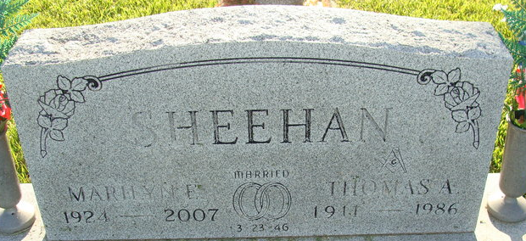
Photo by Alicia Kneuss

Marilyn E. Sheehan, 82 of Decatur passed away Thursday, March 1, 2007 at Woodcrest Nursing Center. She was born in Clay City, Indiana to the late Charles & Elva (Nelson) Deeter. She married Thomas A. Sheehan on March 23, 1946, he passed away on November 8, 1986.
Survivors include 2 sons Patrick (Alyce) Sheehan of Liberty, Indiana, Lee Sheehan of Decatur; 2 daughters Rebecca (Steve) Goble and Karen (Joseph) Garner both of Decatur; 12 grandchildren and 10 great grandchildren.
Marilyn was an active member of Union Chapel United Methodist Church where she was financial secretary for 18 years, Sunday school teacher and held various offices within the church.
She was a former member of the Jolly Housewives, Live and Learn Home Demonstration Clubs, 4-H Leader, Vice Precinct committee women & election board and a lifetime member of the Adams County Historical Society.
Marilyn retired as a bookkeeper from Dean's Milk & Stiefel Grain in Decatur.
Calling hours are from 2-8 pm Saturday, March 3, 2007 at Haggard & Sefton Funeral Home and 2 hours prior to services. Funeral service is 2:00 pm Sunday, March 3, 2007 at Haggard & Sefton Funeral Home. Rev. Edward Karges will be officiating and burial is in Decatur Cemetery.
Memorials are to the church or Family Hospice of NE Indiana.

Haggard & Sefton Funeral Home, Adams County, Indiana
March 2, 2007
**
Indiana, U.S., Death Certificates, 1899-2017
Name Marilyr E Sheehan
[Marilyr E Deeter]
Gender Female
Race Caucasian (White)
Age 82
Marital Status Widowed
Birth Date 19 Mar 1924
Birth Place Clay City Indiana
Death Date 1 Mar 2007
Death Place Decatur, Adams, Indiana, USA
Death Registration Date 2007
Father Charles Deeter
Mother Elva Nelson
Informant Rebecca Goble; daughter; Decatur, Indiana
Burial March 4, 2007; Decatur Cemetery; Decatur, Indiana

