Melvin E. Shaw
July 28, 1914 – January 21, 1990

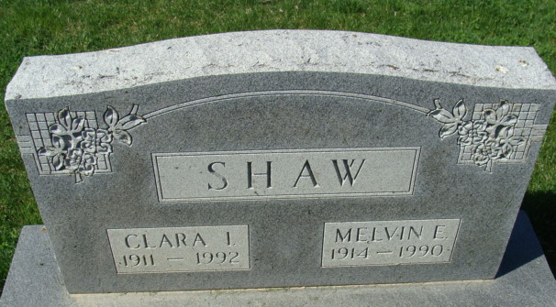
Photo by Alicia Kneuss

Melvin E Shaw
in the Indiana, Death Certificates, 1899-2011
Name: Melvin E Shaw
Gender: Male
Race: White
Age: 75
Marital status: Married
Birth Date: 28 Jul 1914
Birth Place: Columbia City, Indiana
Death Date: 21 Jan 1990
Death Place: Decatur, Adams, Indiana, USA
Father: Frank Shaw
Mother: Daisey Hawk
Spouse: Clara I McBride
Informant: Clara I. Shaw; wife; Decatur, Indiana
Burial: January 23, 1990; Decatur Cemetey; Decatur, Indiana

