Mary Jean (Tricker) Shaw
October 16, 1924 – November 10, 1986

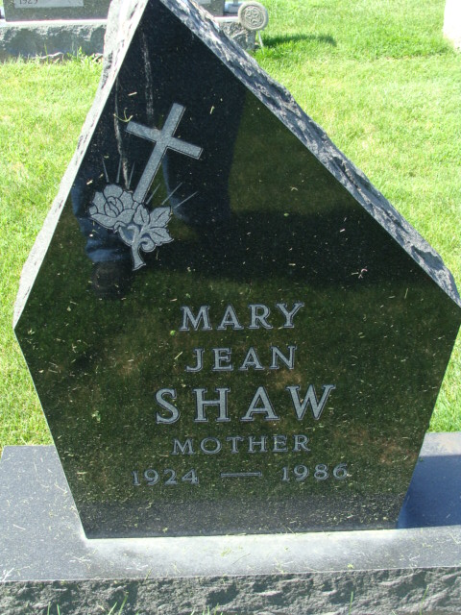
Photo by Alicia Kneuss

Mary Jean Shaw
in the Indiana, U.S., Death Certificates, 1899-2017
Name Mary Jean Shaw
[Mary Jean Tricker]
Gender Female
Race White
Age 62
Marital Status Married
Birth Date 16 Oct 1924
Birth Place Indiana
Death Date 10 Nov 1986
Death Place Fort Wayne, Allen, Indiana, USA
Death Registration Date 1986
Father Jesse O Tricker
Mother Cora E Daniels
Spouse Carl Shaw
Informant Carl Shaw; husband; Decatur, Indiana
Burial November 13, 1986; Decatur Cemetery; Decatur, Indiana

