Mary E. (Dye) Shaw
April 29, 1954 – May 21, 2017

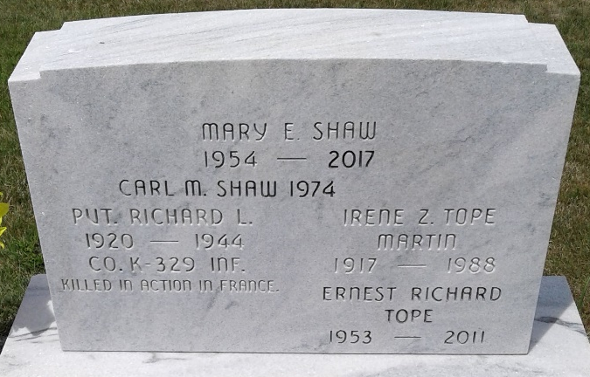
Photo by Deb Curry

Mary E. Shaw, 63, of Decatur, Indiana passed away Sunday, May 21, 2017 at Adams Woodcrest. She was born on April 29, 1954 in Decatur, Indiana to Everett Dye and Ireen Z. Tope. On August 5, 1972, she married Carl A. "Ted" Shaw in Adams County, Indiana and he survives.
She was a member of Grace Fellowship Church in Decatur and the Moose Lodge #242 in Bluffton. Mary was a homemaker and a babysitter for many years. She loved spending time with her children and grandchildren.
Other than her husband, Ted, she is survived by three sons, Carl M. Shaw, Richard J. (Amanda) Shaw, & John L. Shaw all of Decatur; a brother, Dwight Dye of Bluffton and five grandchildren, Mary Jo Shaw; Ashley Victoria Shaw; Lillian Shaw; Braiden Shaw; & Zach Wilson. She was preceded in death by a brother, Richard Tope.
There will be no services per Mary's wishes.
Preferred memorials are Riley Children's Hospital.

Zwick & Jahn Funeral Home, Adams County, Indiana
May 22, 2017

