Marion Matthew Shaw
August 14, 1948 – May 22, 1967

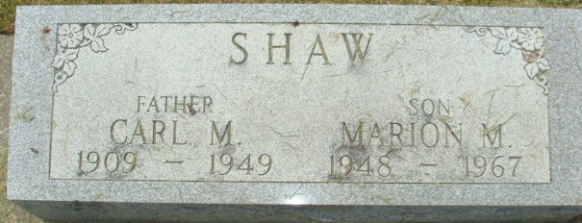
Photos by Alicia Kneuss

DRIVER IS FREE ON BOND AFTER FATALITY
DECATUR – Richard Noble Kraner, 18, of Rt. 1, Ohio City, is free under $1,500 bond on an open charge pending a coroner's inquest later this week in the case of Marion Shaw, 18, of Decatur, Ind., who was killed Monday night when Kraner's car struck the Shaw bicycle.
Shaw, on convalescent leave from the Fort Wayne State Hospital and Training Center, died of a compound skull fracture and internal injuries, according to Richard Linn, Adams County coroner.
Shaw was Decatur's first traffic fatality of 1967. The mishap occurred in the 900 block of Elm St., in the vicinity of the Decatur Bag Service Co. According to investigating officers, the youth was eastbound on Elm St., when his bicycle was struck from the rear by the Kraner auto.
Funeral services were to be held at 2 p.m. today at the Winteregg-Linn Funeral Home with the Rev. Leroy E. Rusher officiating. Burial was to be in the Decatur Cemetery. The accident victim was a lifelong resident of Decatur.
Born Aug. 14, 1948, he was the son of Carl M. and Georgia M. (Hower) Shaw. His father preceded him in death. Mr. Shaw, a member of the Missionary Church, was employed by the Wayne Novelty Co.
Survivors include his mother, Mrs. Georgia M. Johnson of Decatur; three brothers, Carl, Joseph and C. A. Shaw, all of Decatur; two sisters, Mrs. Chancey (Martha) Betz and Mrs. George (Mary Jane) Kahn, both of Decatur; and four half-brothers, Robert, Jr., John, Dewey and Henry Johnson, all of Decatur.

Van Wert Times Bulletin, Van Wert County, Ohio
Wednesday, May 24, 1967

