Joseph E. Shaw, II
June 18, 1973 – January 15, 2002

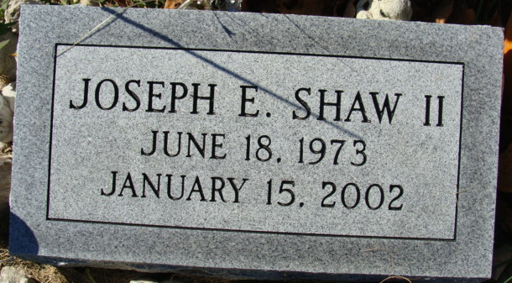
Photos by Alicia Kneuss

Joseph E. Shaw II, 29, of Decatur, a native of Decatur, died Wednesday, Jan. 15, 2003, at Parkview Hospital in Fort Wayne. He worked for Fort Wayne Housing Authority in Fort Wayne.
Surviving are his father, Joseph of Geneva; his mother, Mary Shaw of Decatur; a daughter, Selina M. Shaw of Fort Wayne; twin sisters Bonnie J. and Connie J. Shaw, both of Decatur; and his grandmother, Isabelle Smeltzer of Geneva.
Services are 2 p.m. Saturday at Haggard & Sefton Funeral Home, Decatur, with calling from 11 a.m. until services. Burial will be at Decatur Cemetery.
Memorials are to the family.

News-Sentinel, Allen County, Indiana
Saturday, January 18, 2003

**
Joseph E. Shaw, II, 29

A resident of Decatur, Joseph E. Shaw, II, 29, died at 5:10 pm Wednesday, January 15 at Parkview Memorial Hospital in Fort Wayne. Mr. Shaw was employed by the Fort Wayne Housing Authority.
He was born in Decatur June 18, 1973 to Joseph Shaw, who lives in Geneva and Mary E. Smeltzer Show, who lives in Decatur.
Surviving also are a daughter, Selina M. Shaw of Fort Wayne; twin sisters, Bonnie J. Shaw and Connie J. Shaw, both of Decatur and the maternal grandmother, Isabell Smeltzer of Geneva.
Services will be conducted at 2 pm Saturday at Haggard & Sefton Funeral Home in Decatur, where visitation hours will be Saturday from 11 am until time of services. Burial will be in Decatur Cemetery.
Memorials to the family.

Bluffton News-Banner, Wells County, Indiana
January 17, 2003

**
Indiana, Death Certificates, 1899-2011
Name: Joseph E Shaw II
Gender: Male
Race: White
Age: 29
Marital status: Married
Birth Date: 18 Jun 1973
Birth Place: Decatur Indiana
Death Date: 15 Jan 2003 [sic]
Death Place: Ft Wayne, Allen, Indiana, USA
Father: Joseph E Shaw
Mother: Mary E Smeltzer
Spouse: Suzanne Spillers
Informant: Mrs. Mary E. Shaw; mother; Decatur, Indiana
Burial: January 18, 2003; Decatur Cemetery; Decatur, Indiana

