Joseph E. Shaw
January 20, 1945 – August 24, 2014

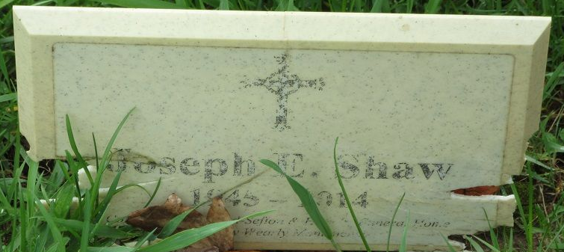
Photo by PLS

Joseph E. Shaw, 69 of Decatur, IN died on Sunday, August 24, 2014 at Chalet Village in Berne. Joseph was born on January 20, 1945 in Decatur, IN to the late Carl and Georgie (Hower) Shaw.
Joseph detailed vehicles for Phil L. Macklin Co.
He is survived by his daughters Bonnie J. Shaw and Connie J. Shaw, and his brothers Bud (Sarah) Shaw, Ted (Mary) Shaw, Johnny Johnson, Bobby Johnson, and Henry Johnson all of Decatur, as well as his sister Mary Kahn, of Bryant, IN and four grandchildren.
He was preceded in death by his son Joseph E. Shaw II, his granddaughter Tiffany Nicole Spillers-Shaw, and his brother Dewey Johnson.
Visitation will take place at the Haggard – Sefton & Hirschy Funeral Home on August 28th, 2014 from 9:00 a.m. – 10 a.m., with the funeral services being held at 10 a.m. Pastor Rex Grant will be officiating and burial will take place in the Decatur Cemetery.
Memorials may be made to the family.

Haggard-Sefton & Hirschy Funeral Home, Adams County, Indiana
August 25, 2014

