Clara I. (McBride) Shaw
July 21, 1911 – June 2, 1992

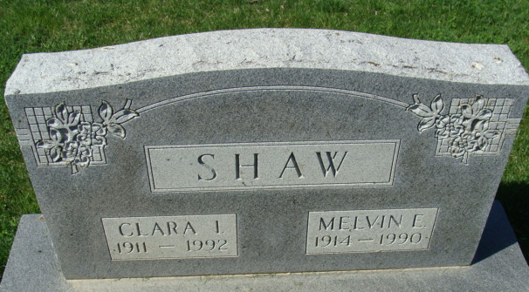
Photo by Alicia Kneuss

Clara I Shaw
in the Indiana, Death Certificates, 1899-2011
Name: Clara I Shaw
[Clara I Mcbride]
Gender: Female
Race: White
Age: 80
Marital status: Widowed
Birth Date: 21 Jul 1911
Birth Place: Christian County, IL
Death Date: 2 Jun 1992
Death Place: Berne, Adams, Indiana, USA
Father: Guy E Mcbride
Mother: Teresa M Richardson
Informant: Sharon Martz; niece; Decatur, Indiana
Burial: June 4, 1992; Decatur Cemetery; Decatur, Indiana

