Carl Martin Shaw
August 24, 1909 – September 29, 1948

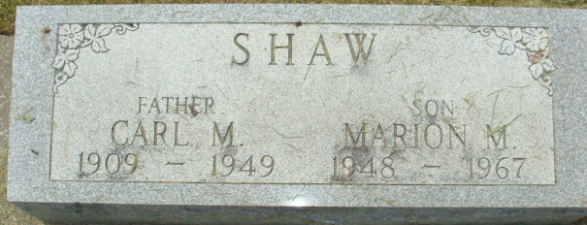
Photos by Alicia Kneuss

NATIVE OF BLUFFTON DIES AT DECATUR
Carl M. Shaw, 39, of Decatur, a native of Bluffton, died Wednesday morning at the Adams County Hospital. Death was caused by carcinoma. He had been ill two years.
Born in Bluffton Aug. 24, 1909, he was a son of Lewis and Carrie R. Shaw, and had lived in Decatur for the past 11 years.
Surviving are his wife, Georgia; six children, Martha, Carl, Mary Jane, Joseph, Carl A. and Marion Shaw, all at home, and two sisters, Mrs. Dora German, of Ohio City, O., and Mrs. Merna Lockwood, of Bluffton. Two sisters are deceased.
Funeral services will be held at 1 p.m. Friday at the Gillig & Doan Funeral Home in Decatur, the Rev. H. J. Weldy officiating. Burial will be in the Decatur Cemetery.

Bluffton News Banner, Wells County, Indiana
Thursday, September 30, 1948

