Carl Anthony Shaw
January 18, 1947 – January 20, 2020

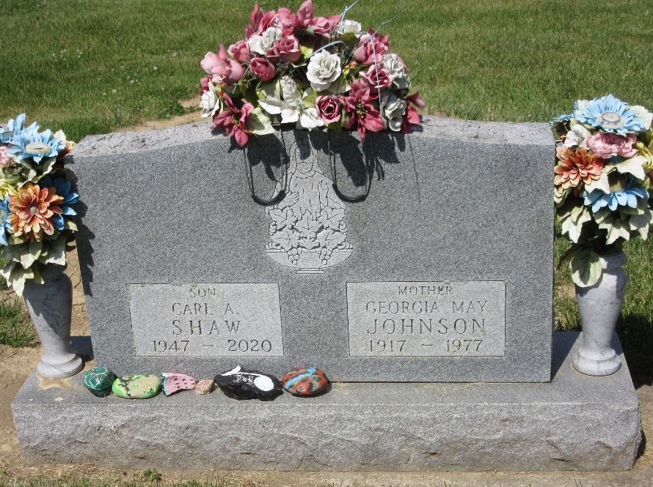
Photos by PLS

Carl A. (Ted) Shaw, 73, of Decatur, IN passed away at his residence on Monday, January 20, 2020. Carl was born on January 18, 1947 in Decatur to the late Carl M. and Georgia M. (Hower) Shaw. On August 25, 1974, Carl married Mary E. Dye. She preceded him in death on May 21, 2017. Carl was retired from the Decatur Casting.
Survivors include, 3 sons, Carl M. Shaw, Richard J. (Amanda) Shaw and John L. (Ashley) Shaw all of Decatur; 2 brothers, Henery “Hank” Johnson and John Johnson both of Decatur; a sister Mary Jane Kahn of Bryant; 8 grandchildren, Mary Jo, Braiden, Ashley, Zach, Rileigh, Lillian, Raven and Dillon. He was preceded in death by 5 brothers, Dewey and Robert “Bobby” Johnson, Joe, Marion and Carl Shaw and a sister, Martha.
Funeral Service will be held at 11:00 a.m. on Wednesday, January 22, 2020 at Haggard-Sefton-Hirschy & Zelt Funeral Home with calling 2 hours prior from 9:00-11:00 a.m. Pastor Dan York will be officiating and burial will follow in Decatur Cemetery.
Preferred memorials to Riley Children’s Hospital.

Haggard & Sefton Funeral Home, Adams County, Indiana
January 21, 2020

