Phyllis JoAnn (Meyer) Shannon
August 26, 1929 – November 11, 2007

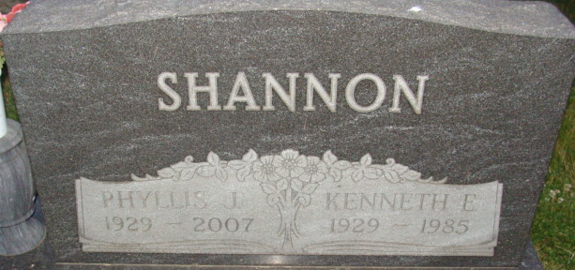
Photo by Alicia Kneuss
JoAnn Shannon, 78, of Decatur, died Sunday, Nov. 11, 2007 at Bluffton Regional Medical Center. Born in Wells County to Glen and Gladys (Sills) Meyer on Aug. 26, 1929, she married Kenneth E. Shannon on Dec. 11, 1949; he preceded her in death on Nov. 13, 1985.
Mrs. Shannon was a homemaker.
Surviving relatives include two sons, Rick L. (Tam) Shannon of Mendon, Ohio and Pat D. Shannon of Decatur; three daughters, Deb Shannon, Rita (Ed) Combs and Carri Shannon, all of Decatur; two brothers, Kenny (Sue) Meyer of Montpelier and Galen (Linda) Meyer of Tipton; two sisters, Patty (Norm) Dobson of Bluffton and Karon (Jim) Bothast of Montpelier; 16 grandchildren and 25 great-grandchildren. Mrs. Shannon was also preceded in death by a daughter, Cindy Hunter, a grandson and a brother.
Funeral services will be at 10 a.m. Saturday, at the Haggard & Sefton Funeral Home in Decatur with Pastor Dan York officiating. Calling hours will be from 3 to 8 p.m. Friday at the funeral home. Burial is at Decatur Cemetery.
Preferred memorials are to Adams County Home Health.

Bluffton News-Banner, Wells County, Indiana
Wednesday, November 14, 2007

