Kenneth E. Shannon
February 1, 1929 – November 21, 1985

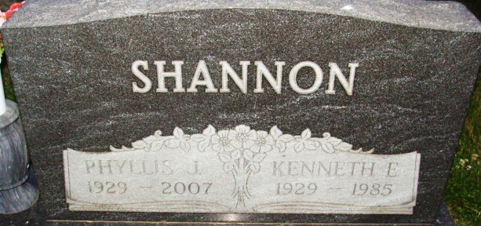
Photo by Alicia Kneuss

Kenneth Shannon
in the Indiana, U.S., Death Certificates, 1899-2017
Name Kenneth Shannon
Gender Male
Race White
Age 56
Marital Status Married
Birth Date 1 Feb 1929
Birth Place Indiana
Death Date 21 Nov 1985
Death Place Indianapolis, Marion, Indiana, USA
Death Registration Date 1985
Father Forrest Shannon
Mother Cloey Harrison
Spouse Phyliss
Informant Phyllis J. Meyer; mother [sic]; Decatur, Indiana
Burial November 30, 1985; Decatur Cemetery; Decatur, Indiana

