Samuel E. Shamp
July 10, 1868 – May 26, 1938

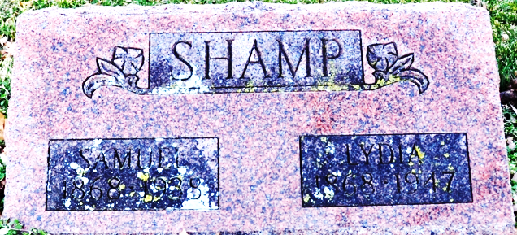
Photo by Deb Curry

Samuel E Shamp
in the Indiana, U.S., Death Certificates, 1899-2017
Name Samuel E Shamp
Gender Male
Race White
Age 69 years, 10 months, 16 days
Marital Status Married
Birth Date abt 1870
Birth Place Fulton Co Indiana
Death Date 26 May 1938
Death Place Decatur, Adams, Indiana, USA
Death Registration Date 1938
Father Jesse Shamp
Mother Rebbeca Shireman
Spouse Lydia
Informant Mrs. Lydia Shamp
Burial May 28, 1938; Decatur Cemetery

