Lydia A. (Yager) Shamp
November 26, 1868 – November 19, 1947

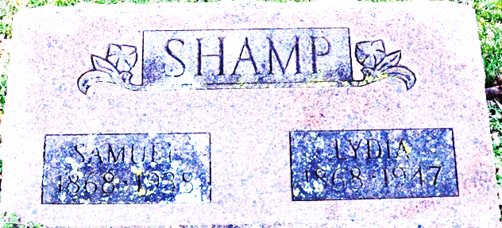
Photo of Deb Curry

ADAMS COUNTY WOMAN SUCCUMBS
FUNERAL SATURDAY FOR MRS. LYDIA A. YAGER SHAMP
Mrs. Lydia A. Shamp, 78, life-long resident of Adams County, died at 11 o'clock Wednesday night at the Adams County Memorial Hospital after suffering a cerebral hemorrhage Wednesday evening. She had been in failing health for several years.
She was born in Adams County Nov. 26, 1868, a daughter of Jacob and Mary Yager. Her husband Samuel Shamp, died nine years ago. She had made her home for several years with a brother-in-law and sister, Mr. and Mrs. S. E. Hite, of 323 South Third Street in Decatur.
Mrs. Shamp was a member of the First Baptist Church, the Pythian Sisters and the Historical Club.
Mrs. Hite is the only near surviving relative. One sister and one brother preceded her in death.
Funeral services will be held at 1 p.m. Saturday at the Black Funeral Home in Decatur and at 1:30 o'clock at the First Baptist Church, with the Rev. Carey R. Moser officiating. Burial will be in the Decatur Cemetery.

Berne Witness, Adams County, Indiana
Friday, November 21, 1947

