Phyllis M. (Bonifas) Shaffer
February 22, 1914 – February 3, 2005

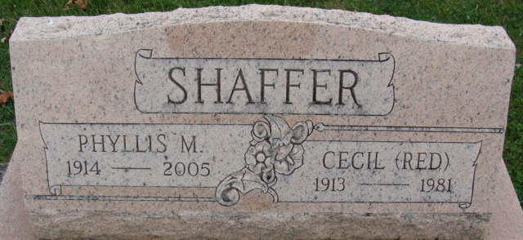
Photo by Alicia Kneuss

Phyllis M. Shaffer, 90, passed away Wednesday, Feb. 3, 2005 at Woodcrest Nursing Center. Her parents were Phillip and Violet (Willison) Bonifas. She married Cecil Shaffer on March 5, 1938 and he passed away on Jan. 4, 1981.
She has 3 sons, Thomas J. Shaffer, Daniel D. Shaffer both of Decatur, Joseph C. Shaffer of Ft. Wayne; 2 daughters, Kathryn A. Conrad of Decatur and Mrs. David (Mary A.) Burns of Noblesville, IN, a sister Marylene Tutewiler of Decatur. 10 grandchildren and 10 great grandchildren. Preceded her in death was her husband, a son John (Pinky) Shaffer, a brother Hollis Bonifas and a sister Thelmalene Bonifas.
Phyllis was a member of Zion United Church of Christ in Decatur, and was a member of the Zion Women's Guild, Adams County Coin Club and the former Jolly Housewives. She was a homemaker and co-owner of Ideal Lunch from 1940-45 and Shaffers Restaurant from 1954-72.
Visitation will be on Sunday Feb. 6th from 11-4 and 6-8 at Haggard & Sefton Funeral Home and the funeral will be at 11:00 am on Monday at Zion United Church of Christ with calling 1 hour prior to service at the church. Rev. Randy Rossman will be officiating and burial will be in Decatur Cemetery.
Memorials are to the church.

Haggard-Sefton & Hirschy Funeral Home, Adams County, Indiana
February 4, 2005

**
Indiana, U.S., Death Certificates, 1899-2017
Name Phyllis M Shaffer
[Phyllis M Bonifas]
Gender Female
Race White
Age 90
Marital Status Widowed
Birth Date 22 Feb 1914
Birth Place Cloverdale, Ohio
Death Date 3 Feb 2005
Death Place Decatur, Adams, Indiana, USA
Death Registration Date 2005
Father Phillip Bonifas
Mother Violet G Willison
Informant Kate Conrad; daughter; Decatur, Indiana
Burial February 7, 2005; Decatur Cemetery; Decatur, Indiana

