Patsy A. (Miller) Shaffer
September 9, 1941 – August 10, 2024

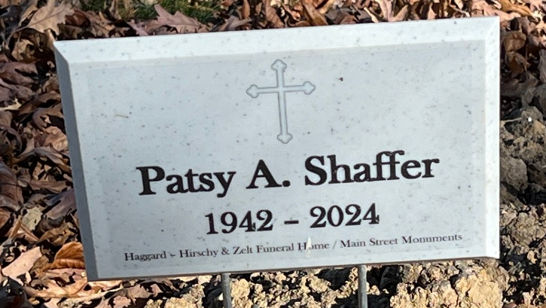
Photo by Deb Curry

Patsy A. “Pat” Shaffer, 82, of Decatur, IN, passed away at her residence on Saturday evening, August 10, 2024. Pat was born in Decatur on September 9, 1941, to the late Nevin and Florence (Tinkham) Miller. On April 2, 1960, she married Harlen E. Shaffer.
Pat was a member of St. Mark’s Church Decatur.
She was a homemaker and did babysitting for many years.
She is survived by her husband of 64 years, Harlen E. Shaffer of Decatur; 2 daughters, Laura J. (Gary) Pinney and Kelly J. Miller both of Decatur; a brother, Carl (Linda) Miller of Decatur; 5 grandchildren, Jason Pinney, Angela McEwen, Josh Gage, Annika Miller, and Kade Miller; 5 great grandchildren, Kali, Jaydon, Bree, Corbin and Rylan.
Pat was preceded in death by a daughter, Teresa J. Gage; a brother, Robert Miller and a sister, Carolyn Shaffer.
Visitation will be on Wednesday, August 14, 2024 from 3:00 – 6:00 p.m. at Haggard-Hirschy & Zelt Funeral Home, followed by a 6:00 p.m. funeral service, with Rev. David Reed officiating. Private family burial will take place on Thursday in Decatur Cemetery.
Preferred memorials are to Wounded Warrior Project or St. Jude Children’s Hospital.

Haggard & Sefton Funeral Home, Adams County, Indiana
August 11, 2024

