Lula V. (Wolfe) Shaffer
June 5, 1916 – November 1, 2000

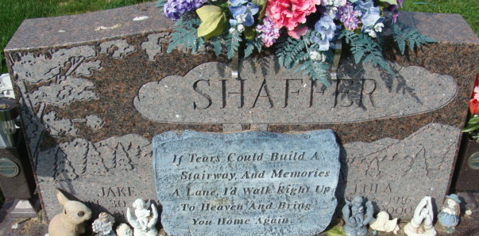
Photo by Alicia Kneuss

Lula V. Shaffer, 84, of Decatur died Wednesday, Nov. 1, 2000, at home.
The Wren, Ohio, native was a homemaker.
Surviving are sons Donald S., Harlen E., Jerry W., David A., Larry D. and Terry L., all of Decatur; daughters Ilene Dailey of Berne, Pat Belew of Nannelly, Tenn., Bonnie Griggs of Owensboro, Ky., and Barbara M., Debra K. and Nancy J. Shaffer and Connie Hess, all of Decatur; a brother, Harold Wolfe of Muncie; 29 grandchildren; and 36 great-grandchildren.
She was preceded in death by her husband, Jake, a son, Charles J., five brothers and a sister.
Services are 2 p.m. Saturday at Zwick & Jahn Funeral Home, Decatur, with calling from noon until services. Calling is also from 7 to 9 p.m. today and also from 1 to 4 and 6 to 9 p.m. Friday. Burial will be at Decatur Cemetery.
Memorials are to the donor's choice.
News-Sentinel, Allen County, Indiana
Thursday, November 2, 2000
**
Indiana, U.S., Death Certificates, 1899-2017
Name Lula V. Shaffer
[Lula V. Wolfe]
Gender Female
Race White
Age 84
Marital Status Widowed
Birth Date 5 Jun 1916
Birth Place Wren Ohio
Death Date 1 Nov 2000
Death Place Decatur, Adams, Indiana, USA
Death Registration Date 2000
Father Davis Wolfe
Mother Nora Meyers
Informant Jerry W. Shaffer; son; Decatur, Indiana
Burial November 4, 2000; Decatur Cemetery; Decatur, Indiana

