Joyce A. (Kirchner) Shaffer
March 30, 1940 – July 16, 2021

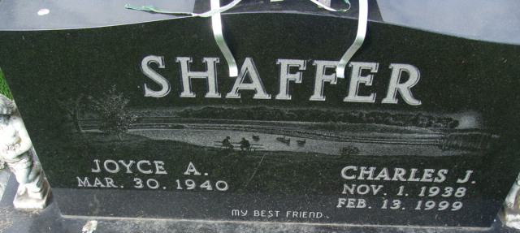
Photo by Alicia Kneuss

Joyce A. Shaffer, 81, of Decatur, Indiana passed away Friday, July 16, 2021 at her residence. She was born on March 30, 1940, in Decatur, Indiana to the late Lloyd M. Kirchner and the late Elizabeth E. (Reed) Kirchner. Joyce married Charles J. Shaffer on June 8, 1958, at St. Peter’s Lutheran Church, Fuelling and he preceded her in death on February 13, 1999.
Joyce was a member of Zion Lutheran Church in Decatur. She worked extensively in the Historical Room at the church. She was also a member of the American Legion Auxiliary in Decatur for many years.
Joyce was a homemaker and had also worked for C.T.S. in Berne for nine years. Joyce loved her grandkids and great-grandkids.
Survivors include her daughter, Tammy (Harold) Duckett of Shipshewana, Indiana; three sons, Lyle (Vicky) Shaffer, Todd (Cari) Shaffer and Cary (Samantha) Shaffer all of Decatur, Indiana; sister, Margene Bradtmueller of Fort Wayne, Indiana; two brothers, Jay (Darlene) Kirchner and Ray (Lynette) Kirchner both of Decatur, Indiana; five grandsons, CJ Shaffer, Mark Shaffer, Tyler Shaffer, Kyle Shaffer, and Ross Shaffer ; and three great-grandchildren, Austin & Trevor Shaffer and Evelyn Shaffer-Todd
In addition to her husband, Joyce was preceded in death by a son, Dennis Lee Shaffer on February 11, 2017.
A funeral service will be held at 11:00 am. Thursday, July 22, 2021, at Zion Lutheran Church in Decatur with Pastor James Voorman officiating. Burial will follow in the Decatur Cemetery.
Family and friends will be received from 2-4 p.m. and 5-8 p.m. Wednesday, July 21, 2021, at the Zwick & Jahn Funeral Home, Decatur and one hour prior to services at the church on Thursday.
Preferred memorials can be given to Zion Lutheran Church.

Zwick & Jahn Funeral Home, Adams County, Indiana
July 16, 2021

