John E. Shaffer
April 10, 1941 – March 30, 1978

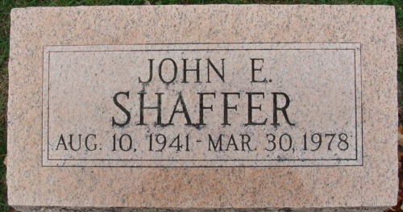
Photo by Alicia Kneuss

John E Shaffer
in the Indiana, U.S., Death Certificates, 1899-2017
Name John E Shaffer
Gender Male
Race White
Age 36
Marital Status Never Married (Single)
Birth Date 10 Aug 1941
Birth Place Indiana
Death Date 31 Mar 1978
Death Place Decatur, Adams, Indiana, USA
Death Registration Date 1978
Father Cecil E Shaffer
Mother Phyllis Bonifas
Informant Cecil Shaffer; Decatur, Indiana
Burial April 3, 1978; Decatur Cemetery; Decatur, Indiana

