Jesse LeRoy Shaffer
August 31, 1923 – April 24, 1948

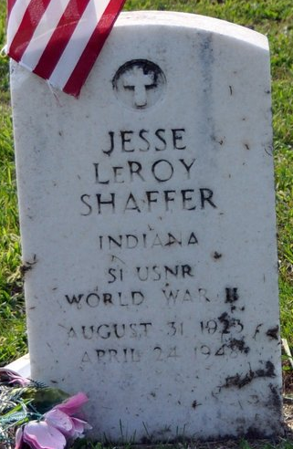
Photo by Deb Curry

Jesse Leroy Shafer
in the Indiana, U.S., Birth Certificates, 1907-1944
Name Jesse Leroy Shafer
Gender Male
Birth Date 31 Aug 1923
Birth Place Decatur, Adams, Indiana, USA
Father Carl Shafer; age 21
Mother Myrtle Bailer; age 16; 1st child
Certificate Number 39606
Roll number 40474_357316
Volume Range 76 - 80
**
U.S., Headstone Applications for Military Veterans, 1861-1985
Name Jesse Le Roy Shaffer
Birth Date 31 Aug 1923
Service Number 874 83 32
Service Branch US Navy Reserve
Unit A/S Navel Personel, Agg-R S. New Aillans Agg-Pacific Cor-13 Joe
Enlistment Date 3 Mar 1943
Discharge Date 20 Jan 1946
Death Date 24 Apr 1948
Cemetery Maplewood Cemetery
Cemetery Location Decatur, Indiana, USA

