Jake L. Shaffer
September 30, 1910 – December 31, 1996

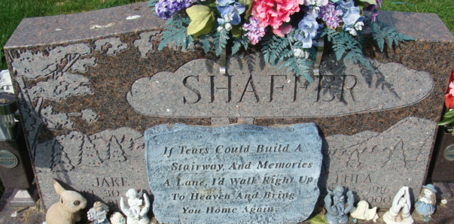
Photo by Alicia Kneuss

Jake L Shaffer
in the Indiana, U.S., Death Certificates, 1899-2017
Name Jake L Shaffer
Gender Male
Race White
Age 87
Marital Status Married
Birth Date 30 Sep 1909
Birth Place Indiana
Death Date 31 Dec 1996
Death Place Decatur, Adams, Indiana, USA
Death Registration Date 1996
Father Fred Shaffer
Mother Mary Smith
Spouse Lula V Wolfe
Informant Lula V. Shaffer; wife; Decatur, Indiana
Burial January 4, 1997; Decatur Cemetery; Decatur, Indiana

