Donald Wayne Shaffer
November 3, 1960 – November 3, 1960

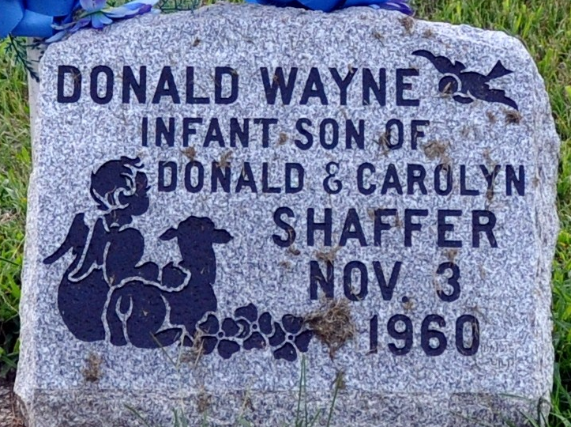
Photo by Deb Curry

Donald Wayne Shaffer from tree Knoef Family
Birth 3 Nov 1960 Decatur, Adams, Indiana, USA
Death 3 Nov 1960 Decatur, Adams, Indiana, USA
Father Donald Sylvester "Bud" Shaffer (1935-2009)

