Donald S. “Bud” Shaffer
October 17, 1935 – December 1, 2009

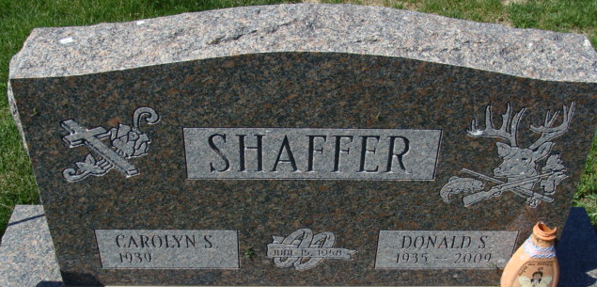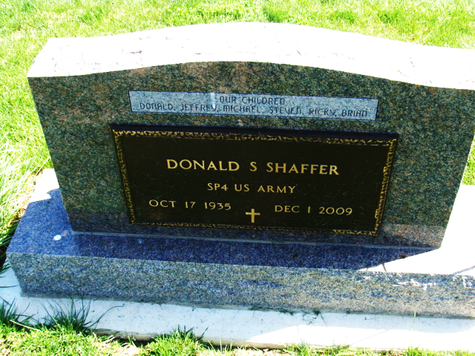
Photo of Alicia Kneuss

Donald S. "Bud" Shaffer, 74 years old of Decatur, Indiana, passed away on Tuesday, December 1, 2009 at his residence. He was born on Thursday, October 17, 1935 in Decatur, Indiana the son of the late Jake L. Shaffer and the late Lula V. (Wolfe) Shaffer. He married Carolyn Sue Miller on June 15, 1958.
Donald served in the United States Army from 1958 to 1960. He worked at Tri-Tec in Decatur and had previously worked at Wolfe's Produce in Decatur.
Surviving are his wife, Carolyn Sue Shaffer of Decatur, five sons; Jeffrey A. (Laura) Shaffer, Michael E. (Michele) Shaffer, Steven W. (Marnie) Shaffer, Ricky L. (Lisa) Shaffer and Brian S. Shaffer all of Decatur, four brothers; Harlen E. (Pat) Shaffer, David A. Shaffer, Larry D. Shaffer all of Decatur and Terry L. (Carla) Shaffer of Convoy, Ohio, six sisters; Mrs. Charles (Ilene) Dailey of Berne, Mrs. Billy (Bonnie) Griggs of Owensboro, Kentucky, Barbara M. Shaffer, Mrs. Allen (Connie) Hess, Debra Shaffer and Nancy J. Shaffer all of Decatur, twelve grandchildren; Mindy (Eric) Uhlman, Jackquelyn (Lucas) Faulk, Jennifer (Zachary) Chilcote, Jessica Shaffer, Jillian Shaffer, Ashley Shaffer, Samantha Shaffer, Sarah Shaffer, Corey Shaffer, Ricky Shaffer, Kurtis Shaffer and Jakob Shaffer and three great-grandchildren; Cayden Shaffer, Logan Uhlman and Rilee Uhlman.
Preceding Donald in death were one son, Donald Wayne Shaffer, one grandson, Justin Shaffer, two brothers; Charles and Jerry Shaffer and one sister, Patsy Belew.
Funeral services will be held at 10:30 Saturday, December 5, 2009 in the Zwick & Jahn Funeral Home with Pastor Rex Grant officiating. Interment will follow in the Decatur Cemetery. Friends will be received from 6:00 p.m. to 8:00 p.m., Thursday, December 3 & 2:00 p.m. to 5:00 p.m. & 6:00 p.m. to 8:00 p.m., Friday, December 4, 2009 in the Zwick & Jahn Funeral Home, Decatur.
Preferred memorials are to the family.

Zwick & Jahn Funeral Home, Adams County, Indiana
December 2, 2009

