Dennis Lee Shaffer
March 30, 1968 – February 11, 2017

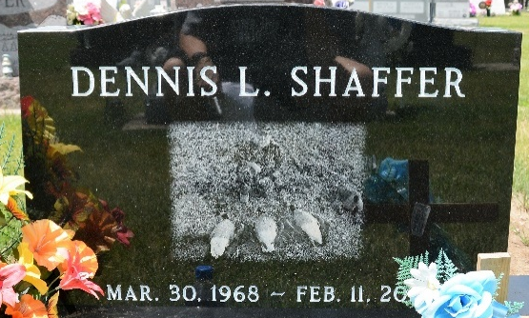
Photo by Deb Curry

Dennis Lee Shaffer, 48 years old of Decatur, IN, passed away on Saturday, February 11, 2017 in the Adams Memorial Hospital in Decatur. He was born on March 30, 1968 in Decatur, Indiana the son of the late Charles Shaffer and Joyce (Kirchner) Shaffer.
He was a member of Zion Lutheran Church, Decatur; National Rifle Association; Ducks Unlimited; and Blue Creek Conservation Club. Dennis enjoyed hunting, fishing, and spending time outdoors. A family man, Dennis spoiled his nephews to unprecedented levels. Dennis was the type of individual who placed others needs ahead of his own. He was known as the typical jokester and prankster.
Dennis was employed for 30 years by REV RV Manufacturing in Decatur where he worked in the paint department.
Surviving is his mother, Joyce Shaffer of Decatur, IN; sister, Tammy (Harold) Duckett of Decatur, IN; brother, Lyle (Vicky) Shaffer of Decatur, IN; brother, Todd (Cari) Shaffer of Decatur, IN; brother, Cary (Samantha) Shaffer of Decatur, IN; and 5 Nephews: CJ Shaffer, Mark Shaffer, Tyler Shaffer, Kyle Shaffer, and Ross Shaffer.
Funeral services will be held at 10:30 a.m. Wednesday, February 15, 2017 in the Zwick & Jahn Funeral Home - Decatur with Rev. James Voorman officiating. Interment will follow in the Decatur Cemetery. Friends will be received from 3-5 and 6-8 p.m., Tuesday, February 14, 2017 in the Zwick & Jahn Funeral Home - Decatur and one hour prior to services on Wednesday at the funeral home.
Preferred memorials are to Zion Lutheran Radio Program.

Zwick & Jahn Funeral Home, Adams County, Indiana
February 12, 2017

